**Resurfacing Projects**

The process of resurfacing a street typically involves the removal of the existing 2-inches of pavement (milling). The surface layer under the asphalt, also known as agbase, is inspected to look for any base issues or failures that will affect the lifecycle of the pavement. If issues are found, the impacted areas are excavated and agbase (crushed rock) is installed and compacted to provide stability. After the base issue has been repaired, a tack oil is applied on top of the existing surface. This tack oil will help bind the asphalt to the existing surface and produce a durable yet flexible pavement.

|  |  |  |  |  |  |
| --- | --- | --- | --- | --- | --- |
| Projects | Project # | Ward | Status | Budget | Funding |
| North Pecan Place   * West Kenosha Street to South End | ST20130 | 2 | Complete | $107,105 | Street Sales Tax |
| 219th and 96th Street Intersection Improvements | ST21270 | 4 | In Progress | $200,000 | Street Sales Tax |
| East 81st Street- Sight Distance   * East 81st Street - South Colony Avenue to South 63rd Street | ST21280 | 1 | In Progress | $110,000 | Street Sales Tax |
| Timberbrook IV Addition   * South 223rd East Avenue – South End to Northeast End * South 224th East Avenue – East 69th Street to East 68th Street * East 66th Street South - South 223rd East Avenue to East 67th Street South * East 67th Street South – South 221st East Avenue to East 66th Street South * East 68th Street – South 223rd East Avenue to South 224th East Avenue * East 69th Street - South 223rd Avenue to South 224th East Ave * East Norman Street - East 68th Street to Evans Road | ST22130 | 1 | Complete | $210,000 | Street Sales Tax |
| East Houston Street   * Evans Road to South 63rd Street | ST22140 | 1 | Complete | $180,000 | Street Sales Tax |
| Washington Street   * Highway 51 to Evans Road | ST22150 | 4 | Complete | $100,000 | Street Sales Tax |
| Tucson Street   * South Elm Place to South 23rd Street | ST22160 | 4 | Complete | $275,000 | Street Sales Tax |
| South Olive Avenue   * West Florence Street to Tucson Street | ST22170 | 3 | Complete | $130,000 | Street Sales Tax |
| Steeple Chase Addition   * East 37th Court South - West End to South 197th East Avenue * East 37th Place South – South 197th East Avenue to South 200th East Avenue * South 197th East Avenue – Match Line to Match Line * South 200th East Avenue - East 37th Place South to Match Line | ST22180 | 1 | Complete | $50,000 | Street Sales Tax |
| Vandever East- 2nd, 3rd, 4th, and 5th Additions   * South Ash Court – New Orleans Street to North Match Line * South Ash Avenue - New Orleans Street to Kent Street * South Ash Place - South End to North Match Line * South 1st Street - Kent Street to Ithica Place * West Laredo Place – West End to Ash Avenue * West Kent Street - Ash Court to 1st Street * West Ithica Street - Elm Place to Ash Court * West Ithica Place – Ash court to 1st Place * South Elm Avenue – Ithica Street to South End * South Date Avenue – North End to South End * South Cedar Avenue – Ithica Street to North End * South Birch Avenue – Ithica Street to north End * West Gary Street – Elm Avenue to Cedar Court * South Cedar Court - Gary Street to Fulton Street * West Fulton Street – Elm Place to Cedar Court | ST22190 | 4 | Complete | $520,000 | Street Sales Tax |

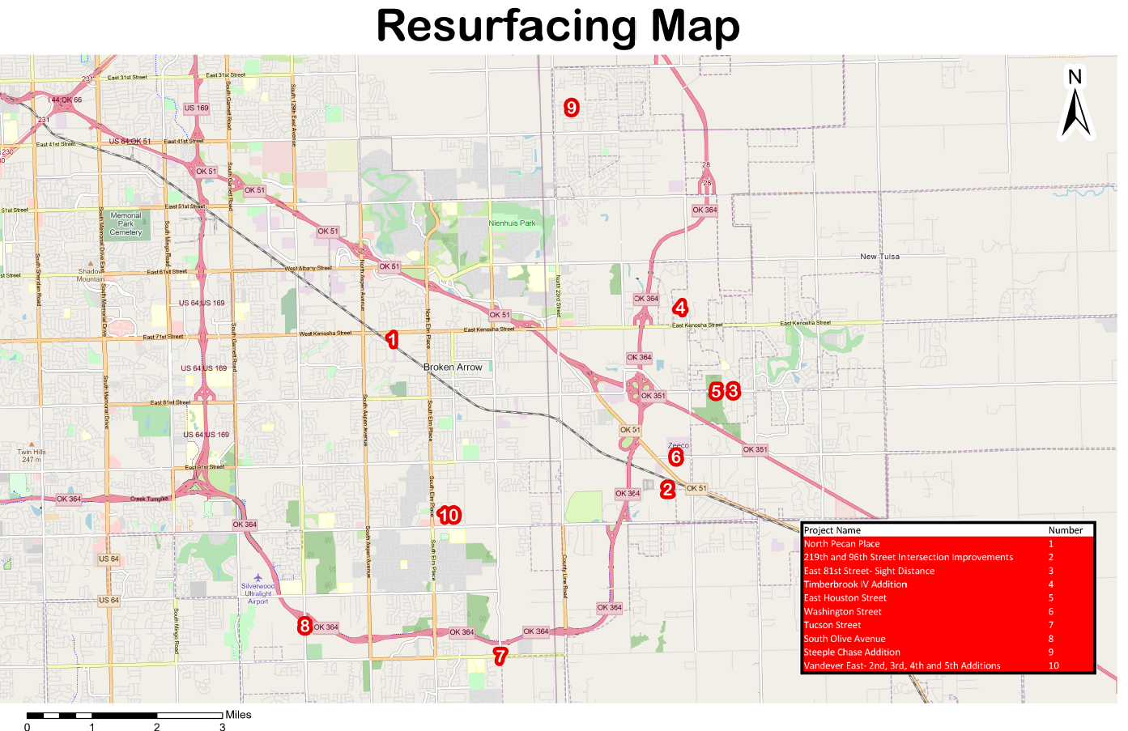

**Concrete Panel Repair Projects**

These projects consist of removing damaged concrete, assessing the subgrade for base failures, compacting the subgrade, doweling in rebar to existing concrete, and pouring new concrete.

|  |  |  |  |  |  |
| --- | --- | --- | --- | --- | --- |
| Projects | Project # | Ward | Status | Budget | Funding |
| Carriage Crossing   * East Concord Street - North 12th Street to East Concord Place * North 15th Street - East Boise Place to East Dover Street * East Concord Place - North 12th Street to North 15th Street | ST1913 | 1 | Complete | $50,000 | Street Sales Tax |
| Turtle Creek   * South Chestnut Avenue - West Louisville Street to West Knoxville Street * South Chestnut Avenue - West Knoxville Street to West Jackson Street * South Chestnut Avenue - West Jackson Street to North Indianola Street * South Chestnut Avenue - North Indianola Street to West Houston Street * West Nashville Place - South Beech Court to North End * West Nashville Street - South Beech Court to East End * West Oakridge Street - South Chestnut Avenue to South Beech Court * West Oakridge Street - South Beech Court to South Beech Avenue * West Oakridge Street - South Beech Avenue to South Aspen Court * West Oakridge Street - South Aspen Court to South Aspen Avenue | ST2004 | 2 | Complete | $189,000 | Street Sales Tax |
| Cedar Spring Estates   * West Pittsburg Street - South Olive Avenue to South Laurel Avenue * South Hemlock Avenue - West Pittsburg Street to North End * South Laurel Avenue - West Richmond Street to North End * West Pittsburg Place - West End to East End   West Quincy Place - South Olive Avenue to South Nyssa Place | ST1914 | 2 | Complete | $232,500 | Street Sales Tax |
| Southpark Estates   * West Utica Street - South Maple Avenue to South Elm Place * South Utica - West Utica Street to North End | ST20010 | 3 | Complete | $183,000 | Street Sales Tax |
| Mitford Bridge   * West Atlanta Street - South Olive Avenue to South Laurel Avenue * West Atlanta Court - West Atlanta Street to South Joshua Avenue * South Laurel Avenue - West Atlanta Court to North End * South Kalanchoe Avenue - West Atlanta Court to North End * South Kalanchoe Place - West Atlanta Court to South End | ST20030 | 3 | Complete | $144,000 | Street Sales Tax |
| Oak Creek South   * South 32nd Street - East Oakridge Street to East Nashville Street * South 32nd Street - East Nashville Street to East Louisville Street * East Memphis Street - South 28th Street to South 29th Street * East Memphis Street - South 29th Street to South 30th Street * East Memphis Street - South 30th Street to South 30th Place * East Memphis Street - South 30th Place to South 31st Street * East Oakridge Street - South 28th Street to South 29th Street * East Oakridge Street - South 29th Street to South 30th Street * East Oakridge Street - South 30th Street to   South 31st Street   * East Oakridge Street - South 32nd Street to South 33rd Street * East Oakridge Street - South 33rd Street to South 34th Street * East Oakridge Street - South 34th Street to East Match Line | ST20050 | 4 | Design Complete | $318,000 | Street Sales Tax |
| Indian Springs Park 2nd Addition   * West Decatur Street - South Elm Place to South Fern Avenue * West Decatur Street - South Fern Avenue to South Gum Avenue * West Decatur Street - South Gum Avenue to South Hickory Avenue   West Decatur Street - South Hickory Avenue to South Juniper Avenue | ST20070 | 3 | Complete | $75,000 | Street Sales Tax |
| Sentinel Industrial Park   * North 15th Street - East Joliet Street to Match Line * North 16th Street - East Joliet to East Iola Street * East Iola Street - North 15th Street to North 16th Street | ST21190 | 4 | Complete | $186,684 | Street Sales Tax |
| Wedgewood   * South Poplar Avenue – West Pittsburg court to West Houston Street * West Oakridge Street – South Walnut Avenue to South Poplar Avenue | ST22100 | 2 | In Progress | $714,850 | Street Sales Tax |
| Steeple Chase   * East 36th Street - South 194th East Avenue to South 200th East Avenue * East 37th Street – County Line Road to South 201st East Avenue * East 37th Place South - South 194th East Avenue to South 195th East Avenue * East 38th Street South – South 194th East Avenue to South 200th East Avenue * South 194th East Avenue - East 36th Street to East 38th Street * South 195th East Avenue - East 37th Place South to East 38th Street * South 197th East Avenue – East 36th Street to East 38th Street South * South 198th East Avenue - East 36th Street to East 38th Street South * South 200th East Avenue – East 36th Street to East 38th Street South | ST22110 | 1 | In Progress | $658,000 | Street Sales Tax |
| * 6100 Center | ST22120 | 2 | Complete | $50,000 | Street Sales Tax |

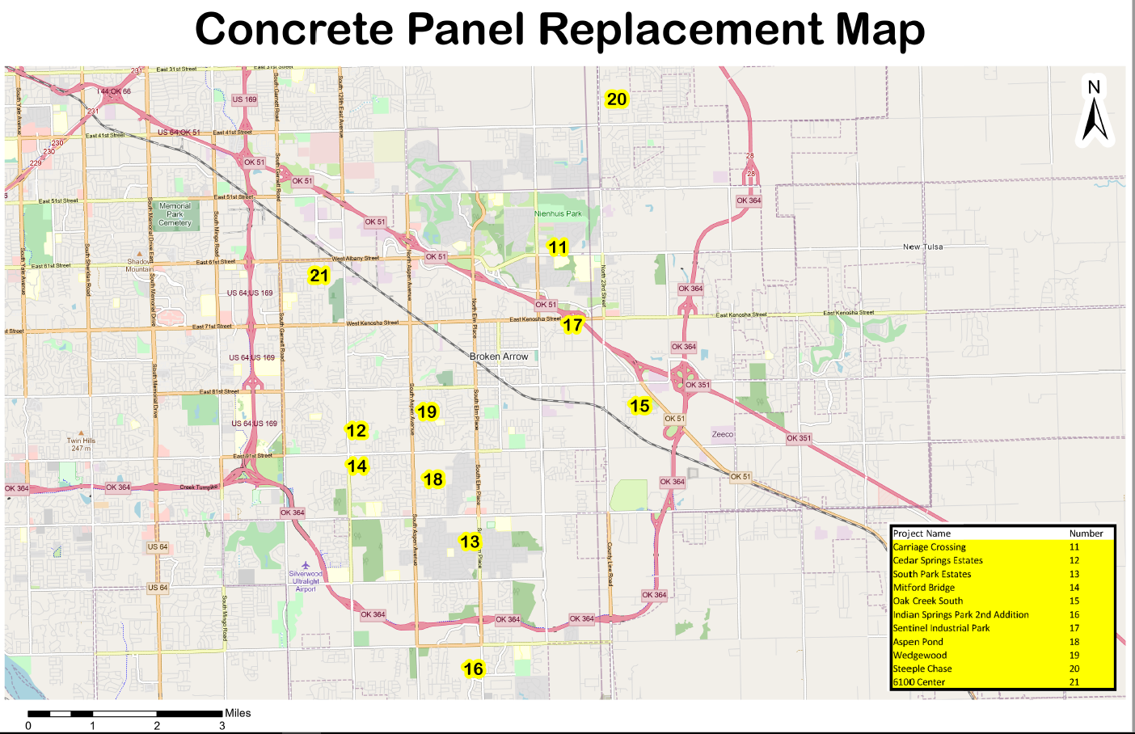

**Street Marking Projects**

When a street is re-marked, the existing markings are refreshed. Once the markings are removed, a street marking vehicle, using a high-powered paint sprayer, will replace the old marks with brighter cleaner road markings.

|  |  |  |  |  |  |
| --- | --- | --- | --- | --- | --- |
| Projects | Project # | Ward | Status | Budget | Funding |
| Various Locations | ST21300 | 1,2,3,4 | Under Construction | $200,000 | Street Sales Tax |

**Street Signal Projects**

This required the addition of a traffic control system, or cabinet at this location.

|  |  |  |  |  |  |
| --- | --- | --- | --- | --- | --- |
| Projects | Project # | Ward | Status | Budget | Funding |
| Evans Road and HWY 51 (B.A. Expressway) | TS20010 | 4 | Complete | $200,000 | Street Sales Tax |
| Signal Rehabilitation   * South Olive Avenue and Creek Turnpike | TS21010 | 3 | In Progress | $380,000 | Street Sales Tax |
| Install Talking Pedestrian Signal Heads   * North Elm Place and West Queens Street | TS22020 | 4 | Complete | $15,000 | Street Sales Tax |
| Replace Control Cabinet and Install Flashing Yellow Arrows   * South Main Street and West Houston Street | TS22030 | 4 | Under Construction | $16,500 | Street Sales Tax |
| Replace Video Detection   * North Aspen Avenue and Highway 51 (North Side) | TS22040 | 1 | Complete | $17,500 | Street Sales Tax |
| Replace Video Detection   * West Kenosha Street and Rhema (East Side) | TS22050 | 2,4 | Complete | $17,500 | Street Sales Tax |
| Replace Control Cabinet, Video Detection, and Install Flashing Yellow Arrows   * South Main Street and East Richmond Street | TS22060 | 4 | Under Construction | $34,500 | Street Sales Tax |
| Replace Control Cabinet, Video Detection, and Install Flashing Yellow Arrows   * North 9th Street and East Juneau Street | TS22070 | 1 | Under Construction | $34,500 | Street Sales Tax |
| Replace Control Cabinet, Video Detection, and Install Flashing Yellow Arrows   * East New Orleans Street and Creek Turnpike (West Side) * New Orleans and Creek Turnpike ( East Side) | TS22080 | 4 | Under Construction | $69,000 | Street Sales Tax |
| Replace control Cabinet, Video Detection, and install Flashing Yellow Arrows   * 23rd Street and Creek Turnpike | TS22090 | 4 | Under Construction | $50,000 | Street sales Tax |
| Replace Control Cabinet   * North Main Street and West Broadway Avenue | TS22010 | 4 | Under Construction | $15,000 | Street Sales Tax |