Calendar Listing
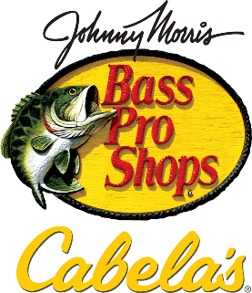

Bass Pro Shops in Broken Arrow invites kids to FREE fishing weekend as part of its annual Spring Fishing Classic
WHAT: Bass Pro Shops and Cabela’s is celebrating the kickoff of fishing season with the largest nationwide fishing sale of the year, the 2022 Spring Fishing Classic.
As part of this event, Bass Pro Shops in Broken Arrow, Ok. is welcoming kids to participate in a variety of free activities all focused on teaching kids how to fish, including their iconic catch-and-release ponds, casting challenges, giveaways and photo downloads.
In addition to the great deals on gear and clothing during the Spring Fishing Classic, Bass Pro Shops offers something for the whole family with its giant aquariums teeming with native fish, wildlife mounts and dioramas, and hand painted murals that celebrate local scenes.
WHEN: Saturday, March 19 & Sunday, March 20, 11 a.m – 4 p.m.
WHERE: Bass Pro Shops
101 Bass Pro Drive
Broken Arrow, Ok. 74012
COST: FREE

Visit www.basspro.com/classic for more information.
# # #

About Bass Pro Shops®
Bass Pro Shops is North America’s premier outdoor and conservation company. Founded in 1972 when avid young angler Johnny Morris began selling tackle out of his father’s liquor store in Springfield, Missouri, today the company provides customers with unmatched offerings spanning premier destination retail, outdoor equipment manufacturing, world-class resort destinations and more. In 2017 Bass Pro Shops acquired Cabela’s to create a “best-of-the-best” experience with superior products, dynamic locations and outstanding customer service. Bass Pro Shops also operates White River Marine Group, offering an unsurpassed collection of industry-leading boat brands, and Big Cedar Lodge, America’s Premier Wilderness Resort. Under the visionary conservation leadership of Johnny Morris, Bass Pro Shops is a national leader in protecting habitat and introducing families to the outdoors and has been named by Forbes as “one of America’s Best Employers.”

